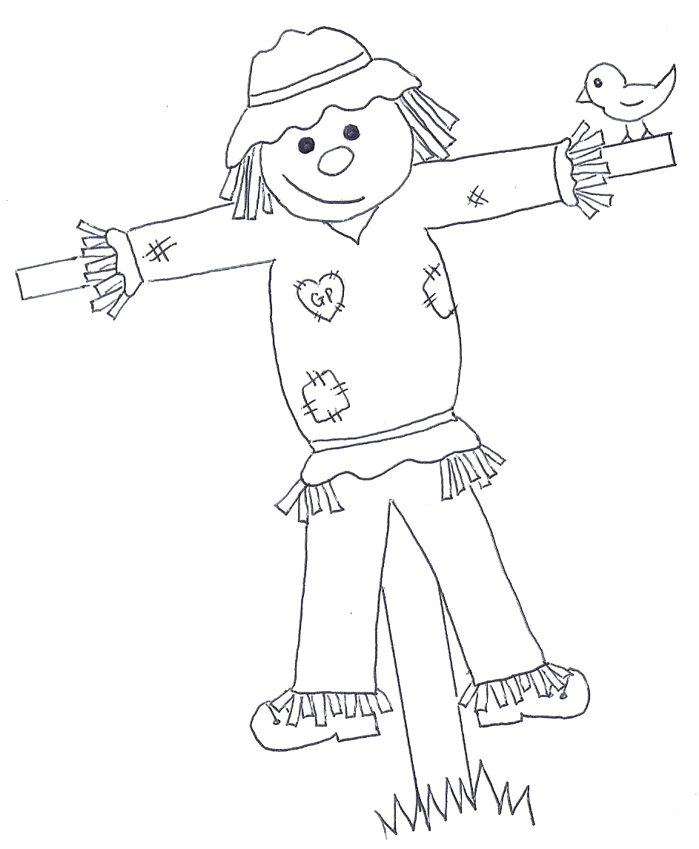
Great Paxton
Scarecrow Festival

TIPS FOR MAKING YOUR SCARECROW

Saturday 10th to Sunday 18th September 2022

Making a scarecrow is great fun for all the family! You don’t need to be a seamstress, artist, or woodworker! With a little forward planning and imagination (or google!) the options are endless!

- Decide on your design and choose a title for your entry.

- Start collecting any clothes and accessories you will need to dress your scarecrow.

- If you are making a more traditional scarecrow, you will need two thin sturdy poles – one for the upright structure, the other for the cross piece to make the arms. Broom handles are ideal. These should be tied together, and the upright pole put securely into the ground. Use rope or an old belt to tie the trousers to the pole (you can put the upright pole through one leg of the trousers).

- Think about where to position your scarecrow so it can be seen by passers-by but is also protected from winds. A seat or against a tree / fence is a good spot.

- If you can get straw this is the best material for stuffing the trousers, torso, arms and head as it holds its shape and is robust. For extra durability and waterproofing you can pack the straw in to plastic bags first.

- A stuffed pillowcase can be used for the head. Felt pens, paints, buttons, pieces of cloth can all be used for the face. Alternatively, you could make a papier-mache head. (If using emulsion or water-based paints, you will need to varnish with a clear varnish before using outside. A cheap varnish can be made by just covering all over with PVC glue. It will be white at first but will dry clear.)

HAVE FUN!!

