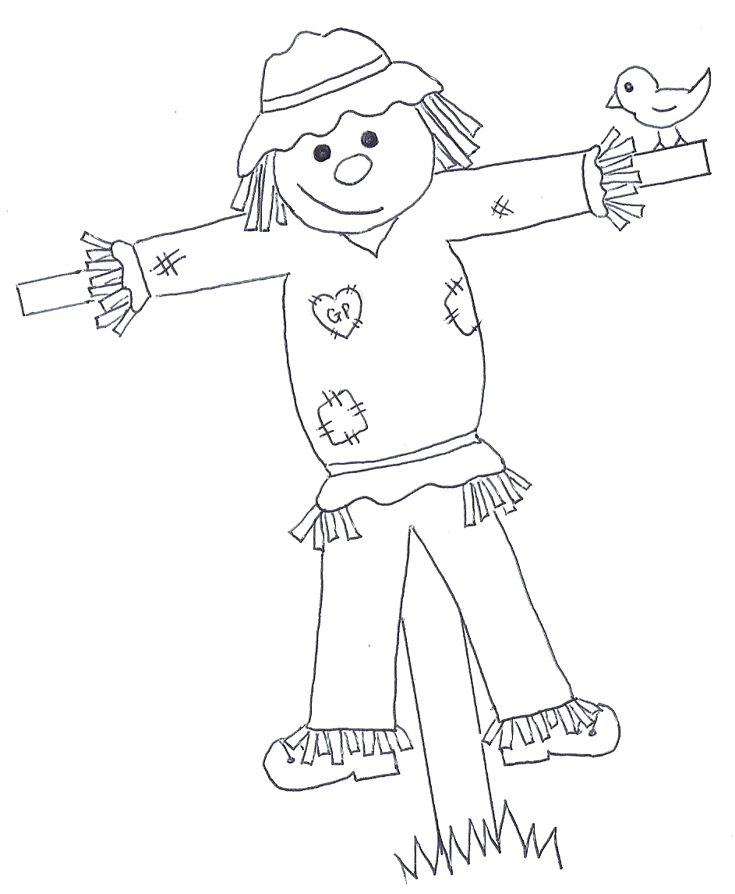
Great Paxton
Scarecrow Festival
ENTRY FORM - SCARECROW FESTIVAL - 10TH TO 18TH SEPTEMBER 2022

First Name |  | Surname
Address |  | Scarecrow Entry Name
Postcode |  | Your allocated official entry number | You will be sent this nearer the time to display next to your scarecrow
Mobile No

Tel No |  | Email
FREE ENTRY! Complete in full and return no later than Sunday 4th Sept to either: |  | Jo Clark  27 Towgood Way  Great Paxton PE19 6RP  GPscarecrow.festival@yahoo.com | Or  The Bell pub  Or  Great Paxton Community Shop
INFORMATION

Only your imagination can limit your design! Go traditional, or as creative as you want! Just ensure the materials you use will withstand the elements for a week as your scarecrow should be in your front garden / where it can be seen by 10am on Saturday 10th until 5pm on Sunday 18th Sept and judging will take place all week by the public. You DO NOT have to use straw and there is no theme for this first year. Only entries that have an official entry number will be eligible to be entered into the competition.
(If you would like to enter but have nowhere to display your scarecrow, contact GPscarecrow.festival@yahoo.com)
Scarecrow Trail sheets will be available from Facebook, the pub and community shop from 10am on Saturday 10th. Use this so you don’t miss any scarecrows on your walk around the village. Follow the map to view all the entries as you are the judges! (Judging by the public will take place for the whole week.) A voting sheet with instructions will be attached to the map. Vote for your favourite by 12noon on Sunday 18th Sept. Votes will be calculated and the winner announced at the pub and on Facebook on Sunday 18th. (If there is a tie in the voting results those entries will be pulled out of a hat to be placed 1st, 2nd, 3rd as required).
£75 cash - 1st Prize - donated by Hire or Buy Group
£50 voucher for The Bell - 2nd Prize
Voucher for Arthur Ibbett Ltd - 3rd Prize

Thank you to

The Bell

Follow us on Facebook at @GreatPaxtonScarecrowFestival to keep up to date with scarecrow news!

